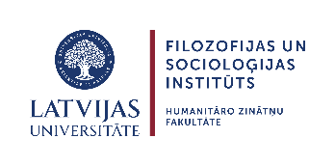



scientific workshop

The Search of Viciebsk Latgale: Rethinking a Borderland region from a Transnational perspective

Riga, May 29, 2026

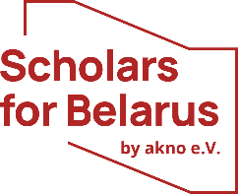
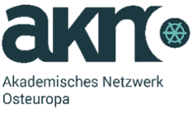


Dear participants,
the goal of this workshop is not so much to present our individual research findings to date, but rather to compare our research directions and identify common threads that could allow us to collectively write a balanced history of Latgale.

Location: Kalpaka bulvāris 4, 2nd floor, Microsoft auditorium

Presentation time for the panels is limited to 5–7 minutes, followed by a Q&A and discussion session. Short abstracts are attached to this program to help make our discussion more productive.

ПРАГРАМА / PROGRAMMA
Прывітальныя словы | 9.30-9.45 | Apsveikuma vārdi
Dr Solveiga Krūmiņa-Koņkova, Director of the Institute of Philosophy and Sociology, Faculty of Humanities, University of Latvia
Dr Anita Stašulāne, Director of the Institute of Humanities and Social Sciences, Daugavpils University
Dr Nina Skepjan, Chair of the Belarusian Institute in Prague
Панэль I.  Дзяржава і эліты | 9.45-10.55 | I sekcija.  Valsts un elites
Moderator: dr Maxim Karaliou
Participants: dr Nina Skepjan (BIP), dr Edvards Seliška (LU),
dr Henrihs Soms (DU), Uldis Vanags, MSc (LVVA),
dr hab. Viktar Shadurski (UWr, online)
кава-паўза | 10.55-11.10 | kafijas pauze
Панэль ІІ. Праблемы ідэнтычнасці | 11.10-12.00 | II sekcija. Identitātes problemātika
Moderator: dr Maija Grizāne
Participants: Andris Uškāns, MSc (DU), dr Ihar Bortnik (IHPAS),
dr Maxim Karaliou (BIP), dr hab. Mirosław Jankowiak (UW)
Панэль ІІІ.  Этна-канфесійны ландшафт | 12.00-13.20 | III sekcija.  Etnokonfesionālā vide
Moderator: dr Inese Runce
Participants: dr Mihails Volohovs (RTI), dr Raisa Zianiuk (i.r.),
Ina Kirņičanska, MSc (DU), dr. Nadežda Pazuhina (LU),
dr Maija Grizāne (DU), Josifs Ročko (MJDL)
абедзенны перапынак | 13.20-14.15 | pusdienu pārtraukums
Панэль IV. Стан даследаванняў | 14.15-15.00 | IV sekcija. Pētniecības aktualitāte
Moderator: dr hab. Mirosław Jankowiak
Participants: dr Stsiapan Zakharkevich (EHU, online),
dr Viktar Yakubau (UW), dr hab. Jerzy Grzybowski (UW, online),
dr Inese Runce (LU)
Выніковая дыскусія | 15.00-16.00 | Noslēguma diskusija
Moderator: dr Nina Skepjan
Participants: all

The Organizing Committee
dr Maxim Karaliou (BIP), dr Inese Runce (LU & DU),
dr Solveiga Krūmiņa-Koņkova (LU), dr Anita Stašulāne (DU),
dr Nina Skepjan (BIP), dr Maija Grizāne (DU)

