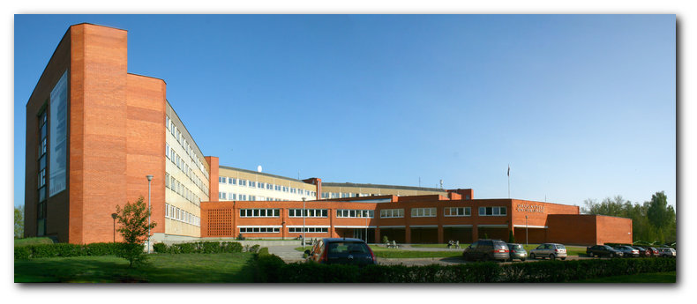

^{20th} International Academic Conference

“Social Sciences for Regional Development 2025”

17.10.-18.10.2025
Daugavpils University
Daugavpils, Latvia

THE CONFERENCE IS ORGANIZED BY
The Institute of Humanities and Social Sciences of Daugavpils University

REGISTRATION FORM
You are welcome fill this form and sent to e-mail ikgadeja.konference@du.lv till 12.10.2025.

Academic degree | Name, Surname | Organization | Address,  Tel./Fax. | E-mail

Information about co-authors (if they are)
Academic degree | Name, Surname | Organization | Address,  Tel./Fax. | E-mail

Please, indicate discipline

Economics | Law | Sociology | Social psychology | Management

Author(-s), country

Title

Abstract (about 300 words (text only))

Deadlines:
- For registration and abstract submission: until 12.10.2025.
- For full paper submission: until 01.11.2025.
- For paying conference fee: until 10.10.2025 after receiving registration confirmation.

Abstract book will be published on the opening of the conference, conference proceedings will be published after the conference.

