Project acronym: BETTER Life

Title: Bringing Excellence to Transformative Socially Engaged

Research in Life Sciences through Integrated Digital Centers

Project number: 101071314

Think Tank Report and Mentorship Programme

Daugavpils University

Authors: Ronalds Krams, Raimonds Ernšteins

BETTER Life PARTNERS:

CESKA ZEMEDELSKA UNIVERZITA V PRAZE (CZU)

PIC 999912570, established in KAMYCKA 129 SUCHDOL,

PRAHA 165 00, Czechia

MARTIN-LUTHER-UNIVERSITÄT HALLE-WITTENBERG

PIC 999871539, established in UNIVERSITÄTSPLATZ 10,

HALLE 06108, Germany

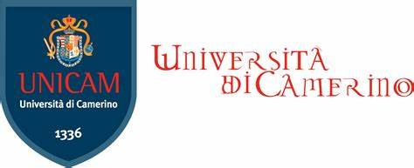

UNIVERSITA DEGLI STUDI DI CAMERINO (UNICAM)

PIC 999845737, established in PIAZZA CAVOUR 19F,

CAMERINO 62032, Italy

ACEEU GMBH (ACEEU)

PIC 896865008, established in WILHELM-SCHICKARD-STR 14,

48149, MÜNSTER, Germany

EESTI MAAULIKOOL (EMU)

PIC 999857280, established in KREUTZWALDI 1,

TARTU 51014, Estonia

DAUGAVPILS UNIVERSITATE (DU)

PIC 999830702, established in VIENIBAS STREET 13,

DAUGAVPILS 5401, Latvia

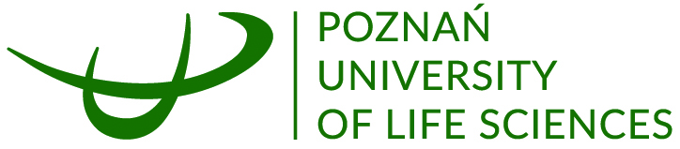

UNIWERSYTET PRZYRODNICZY W POZNANIU (PULS)

PIC 999880463, established in ULICA WOJSKA POLSKIEGO 28,

POZNAN 60 637, Poland

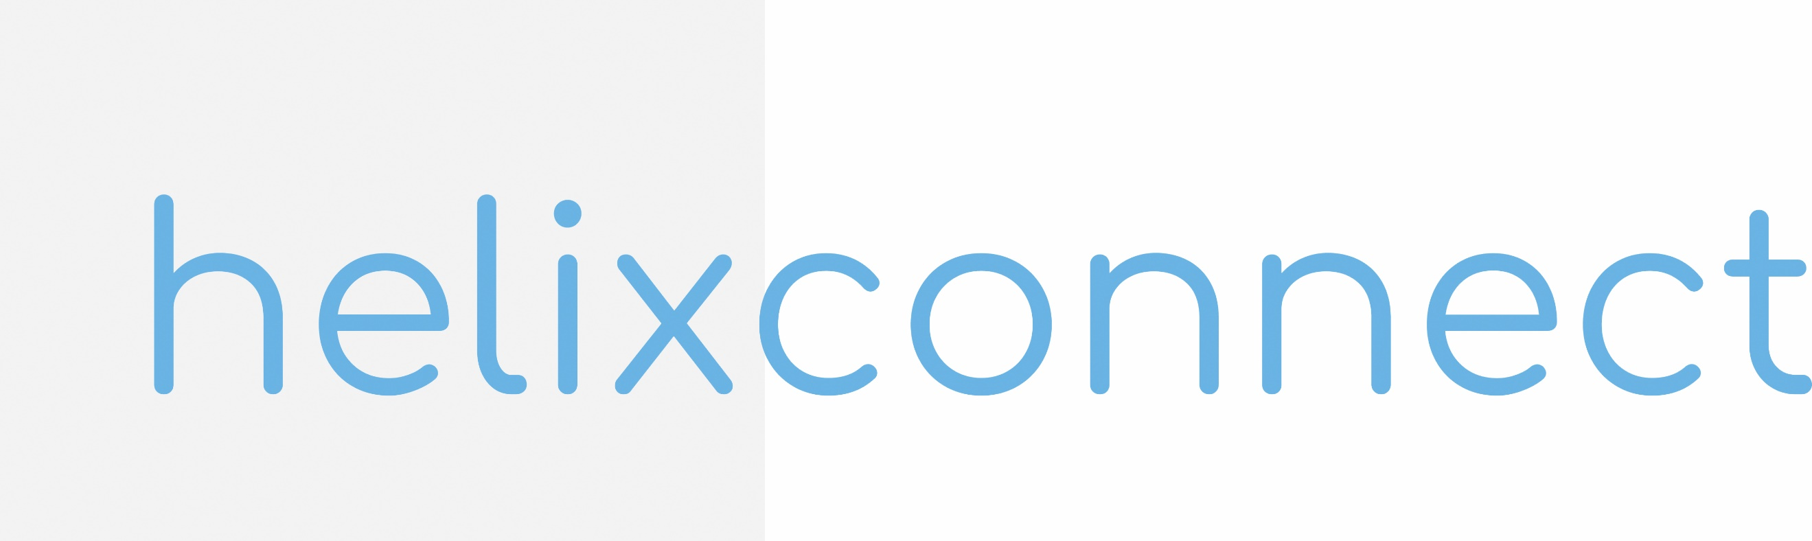

HELIXCONNECT EUROPE SRL (HELIXCONNECT)

PIC 893409868, established in 282A CAMERA 1,

BUCOVAT 307352, Romania

UNIVERZITET EDUCONS U SREMSKOJ KAMENICI

PRIVATNE USTANOVE (EDUCONS)

PIC 973147263, established in VOJVODE PUTNIKA 87,

SREMSKA KAMENICA 21208, Serbia

Table of Content

Introduction 4

Think Tank Session 1 at Daugavpils University (Minutes) 5

Think Tank Session 2 at Daugavpils University (Minutes): Collaboration between Science and Business for Economic Growth 9

Think Tank 3 Session at Daugavpils University (Minutes) 14

Mentoring Program Proposal Outline and Continuation 20

Introduction**:**

As part of the Better Life project, Task 4.2 aims to establish and facilitate regional think tanks that bring together and particularly engage with stakeholders to explore mentorship opportunities and develop sustainable Socially Engaged Research (SER) practices and this was particularly valuable in the case of Life Sciences at DU. The think tank sessions were devoted for discussions and plannings to enhance training programs, also collaboration between early career researchers (ECRs), engagement managers (EMs) and stakeholders from various sectors, including academia, government, business and civil society (starting with as minimum Quadruple Helix model, but continuing with our own renewed/re-designed Quintuple Helix model) providing mentorship opportunities for ECRs to develop their SER skills and practices, promote the use of innovative SER methods in solving real-life challenges faced by regional ecosystems, such as sustainable development, environmental protection and economic growth. Also to foster knowledge transfer between academia and stakeholders, encouraging interdisciplinary and cross-sector cooperation.

# Think Tank Session 1 at Daugavpils University (Minutes)

**Project:** Within the framework of Better Life project “Bringing Excellence to Transformative Socially Engaged Research in Life Sciences through Integrated Digital Centers”, WP4 Capacity Building and Community of Practice

**Seminar session**:Think Tank discussion

**Place:** Hybrid meeting, online and in-person at the Institute of Life Sciences and Technologies at Daugavpils University.

**Date:** 2024, April 30.

The first Think Tank session, held at Daugavpils University, was realized as teamwork with participation of the main stakeholders/experts of DU and Life Sciences, aiming to introduce the project’s goals and to present the Digital Center concept and practice implementation, which, altogether, aims to facilitate collaboration between academia and stakeholders. Stakeholders from various sectors engaged in open discussions on the future of Bootcamps, mentorship programs, and how ECRs can be trained to engage more effectively in SER.

The session was attended by a diverse group of stakeholders, representing practically all main elements of quadruple helix stakeholder groups – academia and training administrators, officers/managers, also PR specialists, national governmental agencies at regional level (nature and environment protection), municipal environmental sector, NGO, and, business-research development center. bringing their unique expertise, idea and perspective to the discussion table.

The attendees included:

1. **Mihails Pupiņš**, the Head of Latgales Zoo, The Herpetologist of the Latgale ecological society;
2. **Valērijs Ašķeļaņecs**, the Augšdaugava Municipal Council Rural Support Service, Senior environmental Management Officer in Lake Management;
3. **Guna Novika**, the State Environmental Service in Latgale region, Head of Natural Resources Department;
4. **Oskars Zuģickis**, Latgale Planning Region; The project manager in Development, Planning and Project Implementation Unit;
5. **Uldis Valainis**, the Life Sciences and Technology Institute leading researcher (former director);
6. **Dainis Lazdāns**, Deputy Director at The State Environmental Service of the Republic of Latvia, The Daugavpils Regional Environmental Board;
7. **Artūrs Škute**, Professor at Daugavpils University (DU);
8. **Raimonds Ernšteins**, Professor at University of Latvia (LU);
9. **Inese Gavarāne**, Director of the research and business center “REBUS”; Daugavpils University;
10. **Edgards Kucins**, Daugavpils University, the researcher of the Institute of Life Sciences and Technology;
11. **Zaiga Vītola**, Project Coordinator, Daugavpils University;
12. **Olga Mickeviča,** Public Relations manager, Daugavpils University.

**Agenda:**

**1.Welcome.**

The session began with a welcome to the participants and a brief introduction of each other.

**2. The “Better Life” project presentation,**

Aims and goals being achieved during the first half of the project, the future plans considering the work packages and DU Digital Center.

**3. The presentation the Digital Center concept and realization practice.**

**4. Clarifying the tasks and aims of future Bootcamps.**

The tasks for the Think Tank sessions were clarified and the idea of mentorship programme was described. Existing mentorship programmes within DU were presented, including a mentorship programme for Ph. D students and new employees aimed at improving educational skills, and a mentorship programme for students.

**5. Open discussion**

The participants shared their ideas and perspectives on what the programme should achieve and in what kind of fields of Knowledge, Skills and Competence they are interested in and the ECR should be taught to build co-operation networks between the HEI and stakeholders.

After related individual evaluations of the situation in the field, comments and general discussion, there were also in some detail formulated comments, proposals and general ideas of participants, particularly on Bootcamps trainings for ECR and mentors, presented here as follows:

**Mihails Pupiņš -** representing Latgales Zoo:

Knowledge on the SER in Life Sciences concept, structure, peculiarities and content, Life Sciences interdisciplinary academia collaborative partnerships with stakeholders in the community, including local organizations, government authorities, and community members. Competences to plan, valorise, provide, realize and continue SER in Life Sciences, combining a set of concepts, methods, and techniques through interdisciplinarity, enhancing academia-multi-stakeholder collaborations. Skills to provide guidance for decision-making on the base of the results and prospects of provided SER in Life Sciences, based on its characteristics, components, and the expected benefits of its use.

**Dainis Lazdāns –** representingThe Daugavpils Regional Environmental Board

Knowledge: Natural sciences and research. Acquired fundamental knowledge in biology, chemistry, and related disciplines. Ability to conduct research, obtain and analyze results.

Skills and Competencies: Socially engaged research: Acquired skills and knowledge related to engaging with society, communicating with various stakeholder groups, and collaborating with non-governmental organizations.

Knowledge: Digital technologies: Acquired knowledge of digital technologies, statistical methods, programming, and data processing for effective and contemporary research and data analysis.

Skills and Competence: Project management and collaboration: Acquired skills and competencies in project management, collaboration with other researchers and partners, as well as the ability to work effectively in a creative team.

Skills: Publicity: Acquired skills related to presenting results both in writing and visually, such as creating scientific articles, presentations, or graphical materials.

**Inese Gavarāne**, Director of the research and business center “REBUS”:

To facilitate SER in Life Sciences it is important to have a mutual understanding and common language between all sides involved – community, stakeholders and researchers. Trust building exercises are crucial for recognition of each other expertise, for development of the skills and assets and for provision of the opportunities for co-learning. Seems nowadays, communication skills becoming one of the most essential skills for career development of the researcher. The style of communication, the tone, the methods and content used for communication should demonstrate respect. It is essential that researchers develop flexibility skills to speed translation of the research results to address the global challenges. Young researchers should better acknowledge their role in modern society. At the same time experienced researchers should support creation of the ecosystem for such research system development where researchers work with their target groups. All parties should respect one another’s time and to be patient during trust building and to appreciate the value of such collaboration for the economy development of the region. To sum-up it is important that young researchers develop their soft skills and gain necessary experience for communication, translation of research results and understanding of the social challenges which their research can address.

**The main idea** of the opinions is the importance of SER in Life Sciences. It emphasizes the need for interdisciplinary collaborations, effective communication, and mutual understanding among researchers, community, and stakeholders. It highlights the significance of trust-building exercises and respect for each other’s expertise and time. It underscores the role of young researchers in society and the need for them to develop soft skills, understand social challenges, and translate research results effectively. Experienced researchers are encouraged to support the creation of an ecosystem conducive to such research, ultimately contributing to regional economic development.

**6. Continuation.**

The next Think Tank session Nr.2. is planned to be held on the beginning of June, with close cooperation with the Research and Business Center “REBUS”.

The Think Tank session Nr.3. will be held on the end of June, where all the main active members of Regional Quadruple Helix stakeholders (8-10 persons) will be invited for final and detailed discussion of Programs draft presented, with the aim to produce the final version of Training Programme.

The Programme will start on July, as the formal PhD program session and most active month for the doctoral students at Daugavpils University.

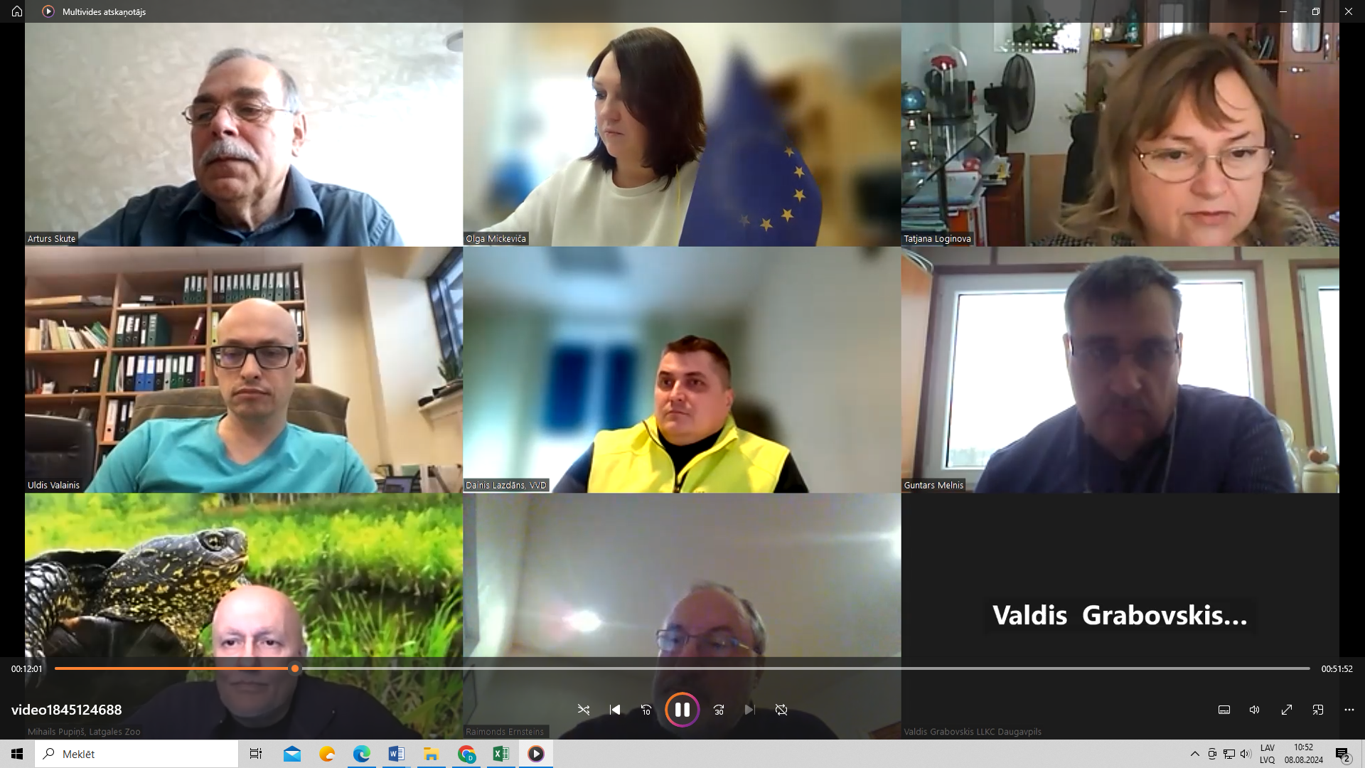

# Think Tank Session 2 at Daugavpils University (Minutes): Collaboration between Science and Business for Economic Growth

**Within the framework of Better Life project “Bringing Excellence to Transformative Socially Engaged Research in Life Sciences through Integrated Digital Centers”, WP4 Capacity Building and Community of Practice, The Think Tank discussion, organized by the Daugavpils University Research and Business Center “REBUS” in collaboration with the Latvian Investment and Development Agency (LIAA) Daugavpils office and the Latgale Planning Region Business Center (LPR LUC), was held on June 26, 202**4.

The second seminar was planned for more expanded and, particularly, also business-based audience, including issues to be discussed as prepared by first Thank Tank seminar experts focused on the collaboration between science and business for regional economic growth. There were altogether 36 participants from academia, business and local government, who explored opportunities for integrating scientific research into business innovation, discussing the role of the REBUS Center, recently established at DU, in promoting these synergies. The session also used a World Café format for group discussions, addressing how to align business needs with scientific research and how to improve the regional research and development ecosystem.

This event aimed to explore and enhance the synergistic potential between scientific research and business innovation, thereby contributing to regional economic growth. The event took place at Daugavpils University, emphasizing the strategic importance of academia-industry collaboration.

#### **Opening Remarks**

The discussion commenced with opening remarks from prominent figures: Arvīds Barševskis, Rector of Daugavpils University; Andrejs Zelčs from LIAA Daugavpils; and Andris Kucins of LPR LUC. Their speeches highlighted the significance of integrating academic research with business strategies to foster an environment conducive to innovation and economic development.

#### **Participants**

The session was attended by a diverse group of stakeholders, representing practically all main elements of quadruple helix stakeholder groups – academia and training administrators, officers/managers, also PR specialists, national governmental agencies at regional level (nature and environment protection), municipal environmental sector, NGO and business-research development center.

The following stakeholders participated in the Think Tank discussion:

1. **Andris Kucins** - LUC Head, Latgales Planning Region
2. **Dina Kumačeva** - Economist, Investment and International Affairs Department, Daugavpils Municipal Administration
3. **Olga Tolmačova** - Head of the Investment and International Affairs Department, Daugavpils Municipality
4. **Iveta Megne** - Senior Commercial Specialist, Augšdaugava Municipality Central Administration
5. **Aina Dzalbe** - Board Member, Krāslava District Partnership Association
6. **Ilja Zlenko** - Board Member, Baltic Development Fund
7. **Ilze Rubeniņa** - Researcher, Lecturer, Daugavpils University
8. **Vitalij Janpavlis** - Director, VITCAKE
9. **Ludmila Aleksejeva** - Associate Professor, Daugavpils University
10. **Aija Brakovska** - Researcher, Daugavpils University
11. **Romāns Suško** - Member, Latvian Textile Industry Association
12. **Līga Aļijeva** - Chairman of the Board, SIA Himalayan International
13. **Jelena Kirilova** - Head of Research, Daugavpils University
14. **Maksims Balalaikins** - Daugavpils University
15. **Diana Arkhangelskaya** - Chairman of the Board, SIA GaloGroup
16. **Maruta Juķeviča** - Department Head, Latvian Chamber of Commerce and Industry
17. **Liene Leikuma-Rimicane** - Innovation Project Manager, Latvian IT Cluster
18. **Svetlana Baltina** - Chief Accountant Deputy, SMD Baltic SIA
19. **Inga Krekele** - Coordinator, BDR Partnership Neighbours
20. **Mārīte Kravale-Pauliņa** - Leading Researcher, Acting Dean, Daugavpils University
21. **Sandra Sprudzāne** - Knowledge and Technology Transfer Specialist, Research and Development Project Manager, Rezekne Technology Academy
22. **Līga Pļaviņa** - Marketing Specialist, Environmental Solutions Company ECOSOUL
23. **Anita Franckeviča** - Board Member, PROTAMS SIA
24. **Oksana Romanova** - GaloGroup
25. **Ivo Dembovskis** - Chairman of the Board, Environmental Project Studio
26. **Toms Andersons** - Deputy Chairman of the Board, Nexis Fibers SIA
27. **Andris Vagalis** - Lecturer, Daugavpils University
28. **Romualds Petrovs**
29. **Pēteris Kozirevs** - Project Manager, InnovoMotion
30. **Rolands Moisejevs** - Daugavpils University
31. **Sergejs Kurņecovs** - Latvian Radio
32. **Aldis Adamovičs** - Latgales Planning Region
33. **Jeļena Dedele** - LIAA
34. **Andrejs Zelčs** – LIAA
35. **Dāvis Grelevskis** - LPR
36. **Katarīna Grāvele** - SIA Neon Underground

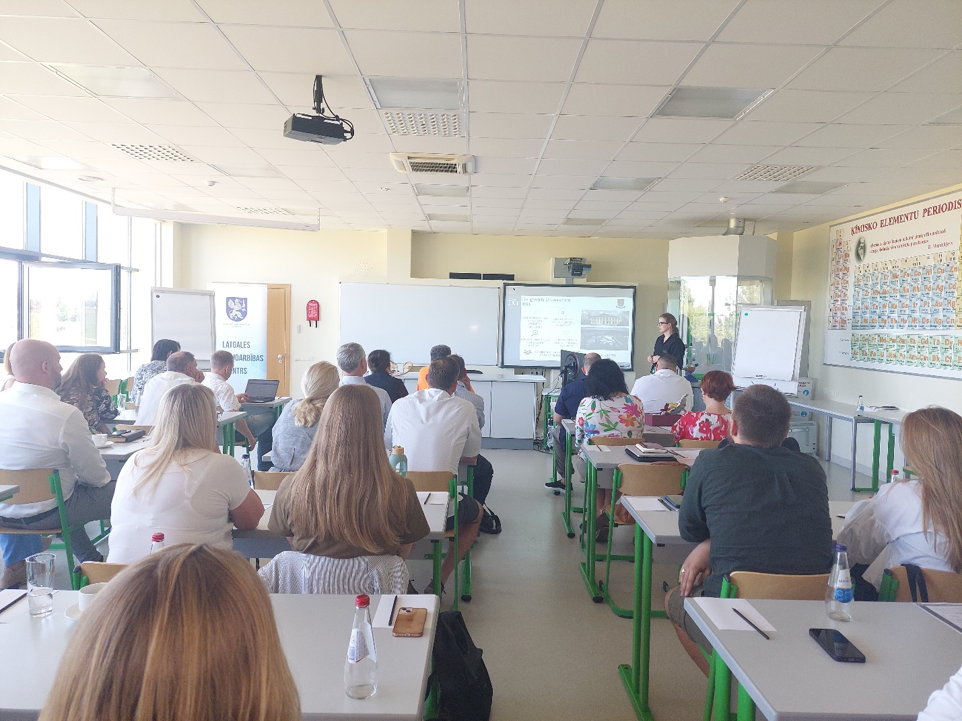

#### **Presentations on Support and Best Practices**

Andrejs Zelčs from LIAA Daugavpils presented on the support available to entrepreneurs and the development of innovations. He detailed various initiatives and resources provided by LIAA to facilitate the translation of scientific research into marketable innovations. This was followed by a presentation on best practices, showcasing successful examples of companies that have effectively collaborated with researchers to drive innovation. These presentations underscored the practical benefits of such collaborations and provided a blueprint for other businesses to follow.

#### **Collaboration Opportunities and REBUS Center**

Inese Gavarāne, acting director of the REBUS Center, along with researcher pitches, discussed the collaboration opportunities available through the Daugavpils University portfolio. The REBUS Center's role in fostering a smart society and innovative region was emphasized, illustrating the center's commitment to bridge the gap between academic research and practical business applications.

#### **World Café Group Discussions**

A significant portion of the event was dedicated to interactive discussions in a World Café format. Participants were divided into groups to address key questions, and the results were summarized as follows:

1. **Aligning Business Needs with Scientific Offerings:**
   * Develop a network of facilitators (e.g., research managers, technology transfer specialists) to bridge the gap between academia and industry.
   * Publish researchers' portfolios, contact information, and business testimonials on the Daugavpils University website.
   * Utilize LinkedIn as a networking tool and business card.
   * Share success stories in accessible language and relevant fields.
   * Conduct research that aligns with current trends and business needs.
   * Organize joint events and discussions.
   * Identify and leverage institutional strengths.
   * Establish a defined organization or platform for matchmaking supply and demand, such as a matchmaking platform.
2. **Requirements for Business and Regional Innovation Development:**
   * Attract investors.
   * Ensure availability of qualified specialists.
   * Foster collaboration partners.
   * Improve information flow.
   * Organize contact exchanges.
   * Enhance marketing efforts.
   * Provide political leadership.
   * Improve infrastructure (e.g., internet access).
   * Implement artificial intelligence (AI) solutions.
   * Enhance digital skills, including data analysis and statistics.
3. **Improving the University Research and Development Ecosystem:**
   * Enhance communication and coordination between the university and businesses.
   * Develop negotiation skills.
   * Advertise service availability.
   * Improve information accessibility.
   * Promote prestige and trustworthiness.
   * Provide financial support for students.
   * Increase internship opportunities.
   * Balance workload effectively.
   * Organize open days at businesses for researchers.
   * Expand research areas and promote inter-university collaboration.
   * Encourage researcher certification.
   * Prioritize research over administrative tasks.
   * Establish a clear and transparent motivation system.
   * Form dedicated research and development teams.
4. **Promoting Innovation in the Business Environment:**
   * Conduct resource audits and preliminary studies.
   * Improve science communication.
   * Organize networking events.
   * Target specific industry audiences.
   * Highlight reputations and scientific achievements.
   * Present innovations at in-person events, information platforms, and exhibitions.
   * Reduce bureaucracy.
   * Share successful examples through media and influencers.
   * Align with political priorities and develop long-term strategies.

#### **Public Participation in Research**

Artūrs Škute, Head of the Ecology Department addressed the role of public participation in the research process, highlighted the needs and challenges associated with involving the public in scientific research, emphasizing the importance of community engagement in fostering a culture of innovation and ensuring that research addresses societal needs.

#### **Discussions with Researchers and Laboratory Tours**

The event concluded with open discussions with researchers and tours of the university's laboratories. This provided practical insight into the ongoing research and development activities at Daugavpils University, demonstrating the institution's capabilities and readiness to collaborate with business entities.

#### **Conclusion**

The Think Tank discussion underscored the critical importance of fostering a robust dialogue between academia and industry. By highlighting best practices, support mechanisms, and collaboration opportunities, the event successfully laid the groundwork for enhanced cooperation aimed at driving regional economic growth through innovation. The active participation and diverse perspectives shared during the discussions, particularly the insights from the World Café sessions, are expected to contribute significantly to ongoing efforts to integrate scientific research with business innovation in the region. 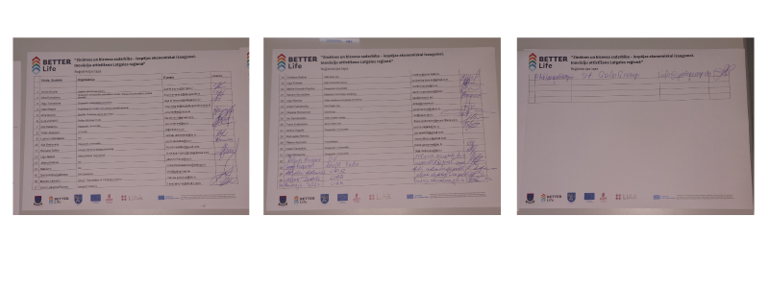

# Think Tank 3 Session at Daugavpils University (Minutes)

**Project:** Within the framework of Better Life project “Bringing Excellence to Transformative Socially Engaged Research in Life Sciences through Integrated Digital Centers”, WP4 Capacity Building and Community of Practice.

**Seminar session**: Think Tank 3 discussion.

**Place:** Online meeting in the ZOOM platform.

**Date:** 2024, August 09.

The last Think Tank session was again planned as Teamwork of the main DU and Life Sciences stakeholders/experts to summarize all Think Tank sessions towards practical decision making. This session, done by participation and collaboration of 10 experts, was dedicated to discussing, first, all those various and multi-thematic recommendations coming out from Think Tank seminar Nr.2 and further on it was oriented to the finalizing of Bootcamps programs and the development of a Digital Center. The Research and Business Center REBUS was introduced as a real practical platform for ensuring the sustainability of project results. Stakeholders acknowledged the importance of Bootcamps in empowering young researchers and promoting interaction between academia and other target groups, as well as approved Bootcamp program outline and proposals for Mentor training program.

The Think Tank 3 session gathered a diverse group of stakeholders, encompassing key representatives from all main elements of the quadruple helix model – academia, research institutions, government agencies, municipal environmental authorities and industry. Participants included university professors, researchers, PR specialists, environmental officers and NGO representatives.

The discussion focused on advancing capacity-building initiatives, enhancing stakeholder engagement through digital tools, and fostering sustainable collaboration between science and society.

A key topic was the planned Bootcamps seminar course for ECRs and mentorship program for EMs, aimed at equipping young scientists with skills in SER through training in communication, interdisciplinary collaboration and research dissemination.

Additionally, the Digital Center Development was highlighted as a key initiative to enhance knowledge sharing and stakeholder interaction, while the Research and Business Center REBUS was introduced as a platform to support innovation and long-term collaboration between academia and industry.

**The attendees included:**

1. **Dainis Lazdāns** - deputy director at the State Environmental Service of the Republic of Latvia, Daugavpils Regional Environmental Board;

2. **Artūrs Škute** - professor at the Daugavpils University, head of the Ecology Department, Institute of Life Sciences and Technology;

3. **Kristīna Skriba** - senior environmental management specialist at the Natural Resources Department, Augšdaugava Municipal Council;

4. **Raimonds Ernšteins** – professor at the Department of Environmental Science, Faculty of Science and Technology, University of Latvia;

5. **Uldis Valainis** – senior researcher at the Institute of Life Sciences and Technology, Daugavpils University;

6. **Guna Novika** - head of the Natural Resources Department, Augšdaugava Municipal Council;

7. **Ronalds Krams** – BETTER Life project assistant at the Daugavpils University;

8. **Inese Gavarāne** – head of the Research and business center “REBUS”, director of the Institute of Life Sciences and Technology, Daugavpils University;

9. **Mihails Pupiņš** - head of the Latgales Zoo, herpetologist of the Latgale ecological society;

10. **Olga Mickeviča** - public relations manager at the International and Public Relations Office, Daugavpils University.

**Agenda:**

1. **Introduction**
   * Welcome, opening remarks and objectives of the seminar.
   * Overview of the focus areas: Bootcamps program development, Digital Center advancement and REBUS (Research and Business Center) as a platform for sustainable project outcomes.
2. **Bootcamps Programs for ECRs and EMs**
   * Discussion on the value of Bootcamps for skill-building and career development in ECRs and EMs.
   * Stakeholder perspectives on the need for continuous capacity-building initiatives.
3. **Digital Center Development**
   * Presentation of the Digital Center as a collaborative and interactive platform purpose and benefits for stakeholders and researchers.
   * Exploration of potential features such as matchmaking functions to enhance stakeholder and academia engagement.
4. **REBUS Research and Business Center Presentation**
   * Introduction of the REBUS Center as a proposed platform for ensuring long-term impact and sustainability of project results.
   * Insights into REBUS mission to support innovative research and development.
5. **Stakeholder Perspectives and Open Discussions** 
   * Feedback from stakeholders across the quintuple helix sectors (academia, industry, government, society and environment) about their views on the necessity and the value of initiatives.
   * Shared ideas and exploration on potential additional functionalities, such as matchmaking services and interactive features, to foster continuous dialogue and ongoing interaction between academia and target groups.
6. **Knowledge Transfer and Methodology Implementation**
   * Reflections on how the Think Tank series facilitated knowledge exchange and adoption of similar methodologies in SER by both, stakeholders and academia.
   * Highlighting and discussion of successful implementation and interest in toolkits developed within the project, indicating potential for further collaboration.
7. **Closing Remarks**
   * Summary of key points, outcomes and encouragement for ongoing multi-stakeholder engagement.
   * Plans for future Think Tank sessions and engagement opportunities.
8. **Open Floor for Q&A and Final Comments**
   * Opportunity for attendees to provide final thoughts, ask questions, and suggest further improvements.
   * Lively discussions on further actions and opportunities to enhance SER capacity in Latvia.

**Summary of Reports**

**Artūrs Škute** opened the session by welcoming participants and emphasizing the importance of multi-stakeholder engagement in the BETTER Life project. He outlined the session's primary focus areas, including the advancement of Bootcamps for ECRs and EMs, the development of the Digital Center and the role of the REBUS Research and Business Center in ensuring project sustainability. He noted that these initiatives would be instrumental in fostering knowledge exchange and strengthening interdisciplinary collaboration across multiple sectors.

Continuing his remarks, he stressed that ensuring the success of these initiatives requires active participation from all stakeholders. He urged attendees to share their perspectives on how the Bootcamps program, Digital Center and REBUS Center could be tailored to maximize impact. He also encouraged an open dialogue on ways to improve existing frameworks and tools to better align research efforts with societal needs.

**Raimonds Ernšteins** introduced the Bootcamps initiative, explaining its purpose in equipping young researchers with methodologies for SER. He highlighted the importance of training young scientists in stakeholder communication, interdisciplinary collaboration and effective dissemination of research outcomes to bridge the gap between academia and practical applications. He detailed how the program would incorporate interactive workshops, mentorship opportunities and real-world case studies to enhance participant engagement.

Further elaborating, he emphasized that Bootcamps would provide a structured learning environment where ECRs and EMs could develop essential skills in engaging with policymakers, industry representatives and the wider community. He underscored the significance of fostering an understanding of the societal impact of research and ensuring that scientific findings contribute meaningfully to policy development and business innovation.

**Ronalds Krams** presented the Digital Center as an interactive platform designed to facilitate cooperation between academia, industry, government and civil society. He detailed the platform’s intended features, including a matchmaking function for researchers and stakeholders, data-sharing capabilities and a collaborative space for interdisciplinary projects. He highlighted that the Digital Center would serve as a dynamic hub for knowledge exchange and resource-sharing.

He further explained that the effectiveness of the Digital Center would rely on continuous content updates and localization to ensure long-term relevance. He stressed the importance of user-friendly design and accessibility, allowing stakeholders from various backgrounds to seamlessly interact with the platform. He also invited suggestions on additional functionalities that could enhance its utility for researchers and external partners.

**Inese Gavarāne** introduced the Research and Business Center REBUS as a key facilitator of industry-academia collaboration. She explained that the center’s mission is to support innovative research and strengthen connections between scientists, businesses, and public institutions. She highlighted that REBUS would play a crucial role in commercializing research outputs and translating academic discoveries into real-world applications.

Expanding on this, she discussed the importance of structured mentorship programs within REBUS to guide young researchers in applying their knowledge effectively. She emphasized the need for targeted funding opportunities and institutional support mechanisms that would help researchers navigate the complexities of industry partnerships, intellectual property management, and entrepreneurship.

**Stakeholders’ feedback**

**Guna Novika** provided feedback on the Bootcamps programs, highlighting the necessity of interdisciplinary collaboration in research training. She stressed that equipping young researchers with cross-sectoral skills would enhance their ability to engage effectively with policymakers, businesses, and local communities. She also noted the importance of fostering early engagement between researchers and industry stakeholders.

Building on this, she emphasized that the integration of practical, hands-on experiences into the Bootcamps programs would be key to success. She recommended including case studies that reflect real-world challenges faced by various stakeholder groups, allowing participants to apply their research knowledge in solving practical problems.

**Dainis Lazdāns** commented on the development of the Digital Center, suggesting the integration of environmental monitoring tools to provide real-time data for policymakers. He emphasized that such functionalities would significantly enhance the practical utility of the platform for government agencies and municipal authorities. He proposed incorporating analytical tools that could visualize trends and facilitate data-driven decision-making.

He further elaborated on the need for interactive dashboards within the Digital Center, allowing users to customize and retrieve relevant datasets efficiently. He highlighted how such features would strengthen collaboration between environmental agencies and academic researchers, fostering evidence-based policymaking.

**Mihails Pupiņš** provided feedback on the Research and Business Center REBUS, stressing the need for interactive feedback systems to enhance accessibility and engagement with research. He suggested incorporating real-time collaboration tools that allow industry stakeholders to communicate directly with researchers. He also emphasized the role of digital tools in facilitating meaningful engagement between academia and business sectors.

Adding to this, he pointed out that REBUS should include a repository of best practices, showcasing successful models of industry-academia partnerships. He advocated for the implementation of training sessions on knowledge transfer strategies, ensuring that research findings could be effectively scaled and implemented within various industries.

**Uldis Valainis** emphasized the importance of translating scientific discoveries into practical applications. He highlighted that fostering collaboration between academia and industry through platforms like REBUS would create opportunities for impactful innovations and long-term sustainability. He called for the development of clear guidelines on how researchers could navigate intellectual property considerations when working with businesses.

He also suggested that REBUS could serve as a bridge for aligning research priorities with industry demands. He encouraged an open dialogue between companies and academic institutions to identify areas of mutual interest, ultimately leading to co-developed research projects that benefit both scientific advancement and economic growth.

Participants also discussed how the Think Tank sessions model facilitates knowledge exchange and interdisciplinary collaboration. Key recommendations included developing a public engagement toolkit, incorporating citizen science initiatives and creating structured collaboration opportunities for local businesses and policymakers. The session concluded with a consensus on the importance of continuous stakeholder engagement and the need for follow-up actions to ensure the successful implementation of these initiatives.

**The main idea** from stakeholder opinions was the need for stronger collaboration between academia, industry and policymakers to ensure that research leads to practical, real-world applications. Participants highlighted the importance of equipping ECRs and EMs with interdisciplinary skills through Bootcamps, fostering structured mentorship within REBUS, and enhancing stakeholder engagement via the Digital Center. Emphasis was placed on making research more accessible, actionable, and aligned with societal needs. Additionally, discussions stressed the necessity of integrating digital tools, real-time data, and interactive platforms to facilitate knowledge exchange and long-term sustainability in research-driven initiatives.

**Key Takeaways**

The Think Tank 3 session emphasized the critical role of multi-stakeholder collaboration in advancing SER and fostering interdisciplinary knowledge exchange. Key discussions centered on the development of the Bootcamps seminar course for ECRs and EMs, the Digital Center as an interactive knowledge-sharing hub, and the Research and Business Center REBUS as a bridge between academia and industry. Stakeholders underscored the need for practical, hands-on training in interdisciplinary research, digital engagement tools for enhanced collaboration and structured mentorship programs to support knowledge transfer. Key recommendations included integrating real-time data tools within the Digital Center, strengthening industry-academia ties through REBUS, and developing public engagement initiatives to enhance research impact. Overall, the session reinforced the necessity of sustained cooperation, digital innovation and structured capacity-building efforts to ensure the long-term success of SER initiatives.

**Conclusions**

The Think Tank 3 session reaffirmed the importance of a multi-stakeholder approach in driving transformative, socially engaged research. Discussions highlighted the necessity of equipping young researchers with interdisciplinary skills, enhancing digital collaboration tools and fostering long-term industry-academia partnerships. The session concluded with a strong consensus on the need for continued engagement, refinement of digital and research platforms and the implementation of structured mentorship and funding mechanisms. Moving forward, stakeholders emphasized the importance of ensuring that research remains accessible, actionable, and aligned with societal needs, reinforcing commitment to sustainable innovation and impact-driven collaboration.

# Conclusions of Think Tanks 1 – 3 and Continuation

The three Think Tank sessions of the BETTER Life project have collectively reinforced the importance of multi-stakeholder collaboration, interdisciplinary capacity-building and digital innovation in advancing SER. From laying the groundwork for stakeholder engagement in Think Tank 1, to emphasizing science-business collaboration for economic impact in Think Tank 2, and finally refining strategies for sustainable knowledge transfer and digital engagement in Think Tank 3, these discussions have set a strong foundation for future initiatives. The key outcomes include the structured development of Bootcamps for ECRs and EMs, the establishment of the Digital Center as a dynamic knowledge-sharing hub, and the operationalization of the REBUS Research and Business Center to strengthen academia-industry ties. Moving forward, continued engagement will focus on implementing these frameworks, enhancing stakeholder participation through interactive digital tools and securing long-term sustainability for SER-driven innovations. If applicable, future Think Tank sessions will aim to refine these efforts, ensuring their alignment with evolving societal and scientific challenges.

**Mentorship Program Proposal Outline**

**Academia and Society in Partnership: Research and Development**

Institute of Life Sciences and Technology

Daugavpils University

The Think Tank sessions with main stakeholders emphasized the critical role of multi-stakeholder collaboration in advancing SER and fostering interdisciplinary knowledge exchange. Partners stressed also the Digital Center as an interactive knowledge-sharing hub, and the Research and Business Center REBUS at the DU as a bridge between academia and industry. Stakeholders underscored the need for practical, hands-on training in interdisciplinary research, digital engagement tools for enhanced collaboration and structured mentorship programs to support knowledge transfer. Key recommendations included integrating real-time data tools within the Digital Center, strengthening industry-academia ties through REBUS, and developing public engagement initiatives to enhance research impact. Overall, the session reinforced the necessity of sustained cooperation, digital innovation and structured capacity-building efforts to ensure the long-term success of SER initiatives.

The think tank sessions organized under Task 4.2 have successfully created a collaborative platform for stakeholders to engage in meaningful dialogue. By providing mentorship and facilitating knowledge transfer, these sessions have encouraged proposed training developments for ECRs and mentors.

Research Capacity Development e-Learning Seminar Series

"Developing public participatory research: the life sciences"

**The general overall** **programs aim is to provide:**

* Guidance on SER methodologies: Stakeholders shared their experiences and provided insights on how ECRs can integrate SER into their projects, focusing on interdisciplinary approaches and stakeholder collaboration.
* Support for research translation: Mentors emphasized the importance of communication and the translation of research results to address societal challenges, helping ECRs to make their work more impactful and relevant to regional stakeholders.

**The general outcomes:**

* Interdisciplinary Collaboration: Think Tank promoted collaboration between academia, industry and civil society, fostering a holistic approach to solving regional challenges.
* Regional Development: Think Tanks have laid the foundation for future collaborations between researchers and regional stakeholders, contributing to the development of sustainable, socially engaged research practices that address both local and global challenges.

The e-seminar training series (3x thematic blocks) is aimed at PHD young scientists, from the fields of life/natural/environmental sciences etc.

**The overall aim of the training process:** to provide participants with an understanding of the design and implementation of socially engaged research (SER) in the life/environmental sciences and the ability to apply the SER-approach to each participant's own research practice, developing the necessary basic knowledge, skills and competences.

The e-seminar training series (training course) is delivered remotely, at the time available to the participants, except for the first contact module, where the information, planning of the course and its assignments, as well as the common introductory lectures/seminars are planned. Further work is planned also in close cooperation with individual mentors too.

**The main content of the course**, in the context of the SER-approach, includes topics such as SER theory and practice, typology and involvement of public interest groups, nature/environment communication (information, education/training, participation and nature/environment friendly actions), public attitudes and social media, development of participatory projects, etc.

At the end of the course, after the presentation and defence of the results of the individual assignments in a discussion seminar, participants will receive the corresponding certificate.

The certificate can also be used for the credit of their DU PhD or MSc B course.

**As a final project paper**, participants produce a project paper advised by the course mentors - Guidelines for the development of participatory research (strategy) for each participant in his/her field of scientific research.

Contact details: Dr. Ronald Krams (ronalds.krams@du.lv)