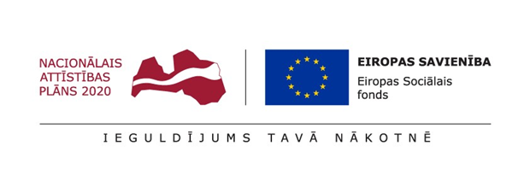

**Extensive digitalization initiatives have been implemented in higher education**

**Within the framework of the project lasting more than a year six Latvian higher education institutions have implemented various digitalization initiatives in higher education, which will contribute to a significant increase of the education quality and the competitiveness of graduates in the labour market. In the future students will have access to various digitalized study courses, an assessment tool for digital competences, as well as the opportunity to acquire knowledge in hybrid audiences.**

Project “Digitalization Initiatives for Improving the Quality of Studies in the field of Strategic Specialization of Higher Education Institutions” is coming to an end, in which the leading partner of the consortium Latvia University of Life Sciences and Technologies (LBTU) has united the other higher education institutions: Rezekne Academy of Technologies (RTA), Daugavpils University (DU), University of Latvia (UL), Ventspils University of Applied Sciences (VUAS) and "Turība" University.

As part of the project strengthening of digital capacity has been carried out in 83 new and existing study courses which will be available for LBTU, UL, DU, RTA, VUAS and Turība. These activities were implemented together with SIA "WeAreDots" and SIA "Baltijas Datoru Akademija" (BDA).

Project manager Ilze Beitāne informs that BDA has developed a tool for assessing students’ digital competences, which was integrated in all higher education institutions involved in the project. An assessment of students' digital competences has been carried out, which showed that areas such as communication and collaboration are at a good level while safety is a competence that needs to be improved.

In addition, 3 multi-functional hybrid audiences have been created to ensure the study process, practical and research seminars at LBTU, RTA and DU. Equipment necessary for the digitalization process at Malnava College has been improved to ensure hybrid learning.

"We are especially proud that during the project the new LBTU student card was created and implemented, which allows to identify LBTU students and provides access to LBTU services, providing access to European university services during mobility. In cooperation with the municipality of Jelgava and within the framework of the MasterCard project *Citypossible* the possibility to integrate e-card into national and city-wide services is being explored”, says I. Beitāne.

Project’s implementation will be finalized on 31st December, within the framework of which all planned results have been achieved. Results achieved will also ensure the further digital transformation for higher education institutions, promoting digital competences of students and teaching staff.

*REACT-EU funding for mitigating of the consequences of the pandemic crisis has been attracted to the European Social Fund's project “Digitalization Initiatives for Improving the Quality of Studies in the field of Strategic Specialization of Higher Education Institutions" (No. 8.2.3.0/22/A/005). The total funding of the project is 2,052,269.47 EUR. Its implementation started on November 1, 2022 and will end on December 31, 2023*.